System and Object Design Proposal
Pearly Gates Cemetery and Crematorium

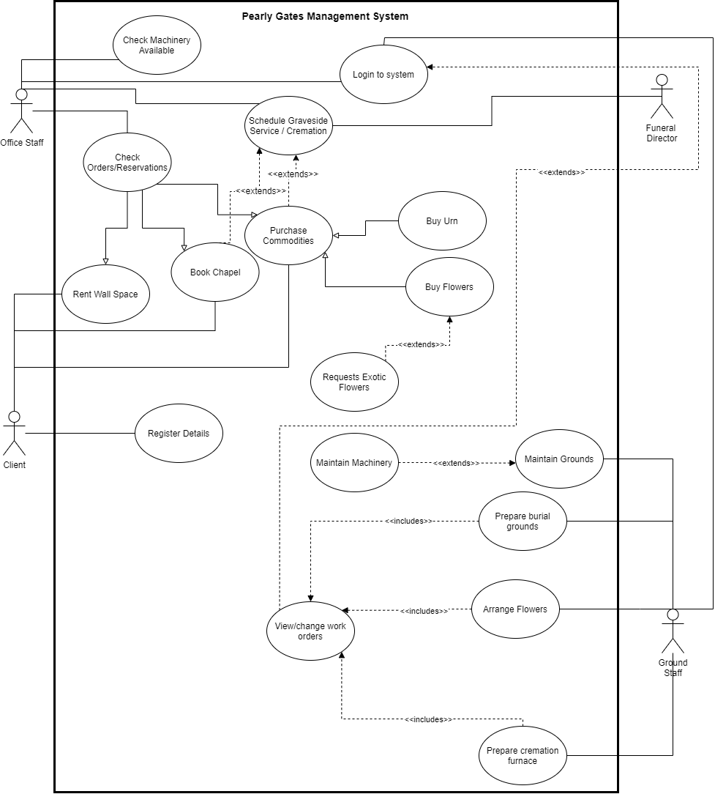
Use Case Diagram:

Intermediate Descriptions and Respective Sequence Diagrams:
Buy Flowers Intermediate Description
Flow of Events

1. The customer enters the Greenhouse and queries for desired Arrangement(s).
2. The florist consults and enters the Arrangement’s ID into the System via the UI.
3. The System checks with the Database to see whether the desired Arrangement(s) are available.
4. The Database returns the message of availability to the UI, which displays for the Florist.
5. Repeat steps 2-4 for each Arrangement.
6. The Florist arranges the flowers.
7. The Florist enters the total amount required.
8. The UI returns a prompt for payment.
9. The customer selects and enters card details.
10. The UI prints a receipt.
11. The Florist gives the customer their Arrangement(s) + Receipt.

Exception Condition

4.1. If there are no available flowers, the Database returns the message of availability to the UI, which displays for the florist, who consults other floral options to the customer.

5.1. If the customer is only purchasing one item, skip step 5.

8.1. If the option of cash is desired, skip step 9.

Buy Urn Intermediate Description
Flow of Events

1. The customer enters the place of sale and queries for an Urn(s).
2. The clerk consults and enters the Urn’s ID into the System via the UI.
3. The System checks with the Database to see whether the desired Urn(s) are available.
4. The Database returns the message of availability to the UI, which displays for the Clerk.
5. Repeat steps 2-4 for each Urn.
6. The Clerk prepares the Urn(s).
7. The Clerk enters the total amount required.
8. The UI returns a prompt for payment.
9. The customer selects and enters card details.
10. The UI prints a receipt.
11. The Clerk gives the customer the Urn(s) + Receipt.

Exception Condition

4.1. If there are no desired Urns left, the Database returns the message of availability to the UI, which displays for the florist, who consults other Urn options to the customer.

5.1. If the customer is only purchasing one item, skip step 5.

8.1. If the option of cash is desired, skip step 9.

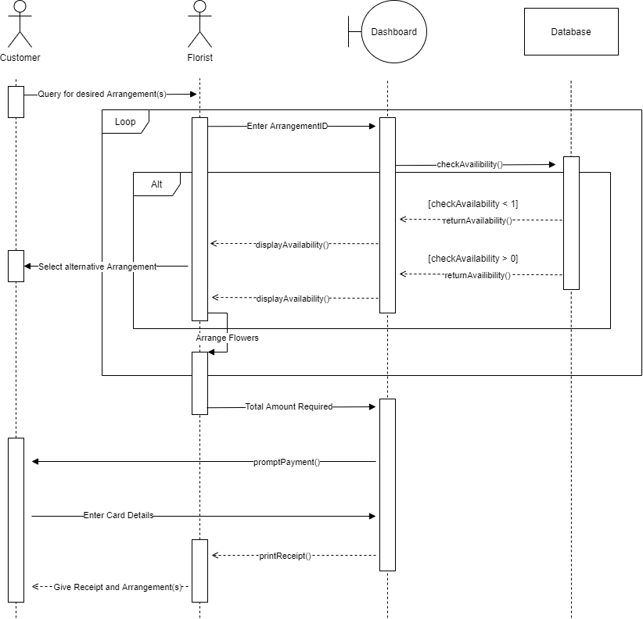
Buy Flowers:

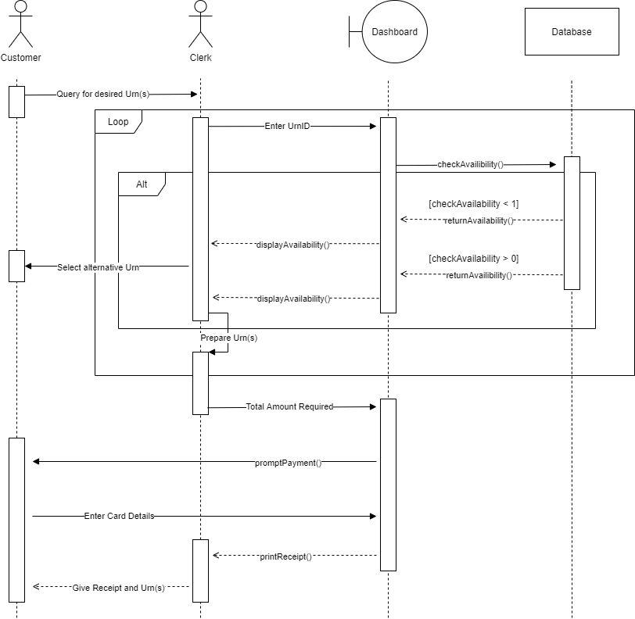
Buy Urn:

Request Exotic Flowers Intermediate Description
Flow of Events

1. The customer enters the Greenhouse and queries for Exotic Flowers.
2. The florist consults and enters the Exotic Flower’s ID into the System via the UI.
3. The System checks the availability of the Flower with suppliers.
4. The System creates a form.
5. The florist fills the contents for the flower order.
6. The florist submits the form.
7. The form is stored within the database for record.
8. The System destroys the current instance of the form.
9. The System produces and OrderID.
10. Repeat steps 2-9 for each Exotic flower request.
11. The UI returns a prompt for payment.
12. The customer selects and enters card details.
13. The UI prints a receipt.
14. The Florist gives the customer their OrderID + Receipt.

Exception Condition

10.1. If the customer is only purchasing one item, skip step 11.

11.1. If the option of cash is desired, skip step 13.

Contact Office
Flow of Events

- Office Staff enters the details requested by Ground Staffs and Funeral director.

- System Provides information for the day’s work.

- All services contact office if there are changes.

- System updates changes if there is.

- System provides updated information.

Exception Condition

1.2. If the details are wrong, the system is unable to provide information.

Request Exotic Flowers:

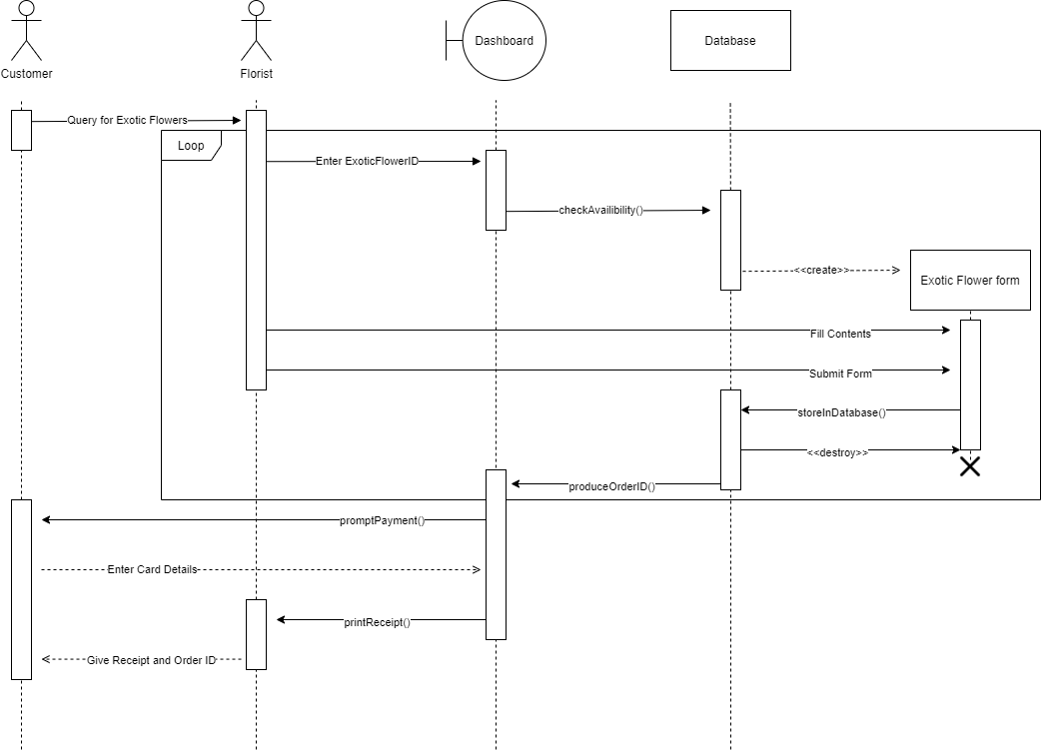
Contact Office:

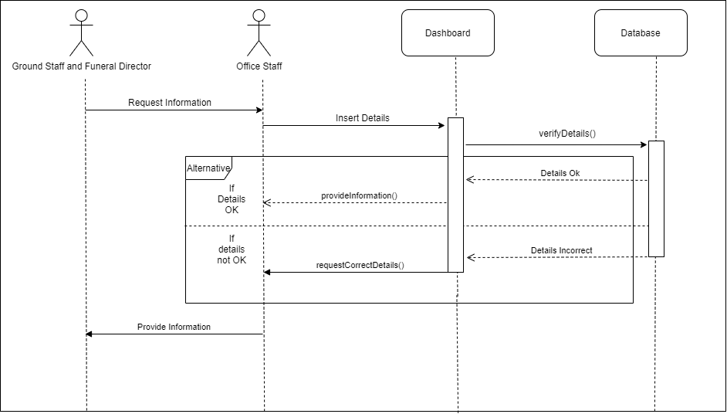
View work order
Flow of Events

- Office staff enters appointments details.

- System looks for the customer appointment details.

- System displays the information required by the staff.

Exception Condition

3.1. If staff has entered the wrong appointment details system will not be able to provide details back.

Schedule Graveside services/Cremation
Flow of Events

- Office staff enters information about customer’s choice of availability.

- System looks for the available slots.

- System selects and schedule one for the user.

- System provides the schedule for graveside service/cremation.

Exception Condition

  - Machinery needed is not available, therefore, scheduling could not be made.
  - Crematorium is not available.

View Work Order:

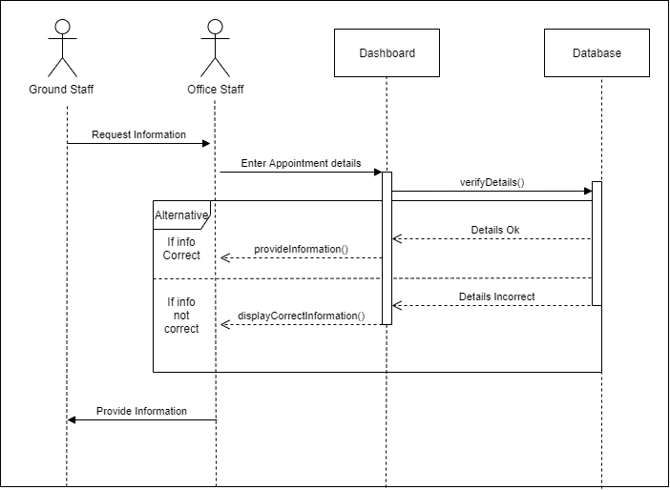
Schedule Graveside Services/Cremation:

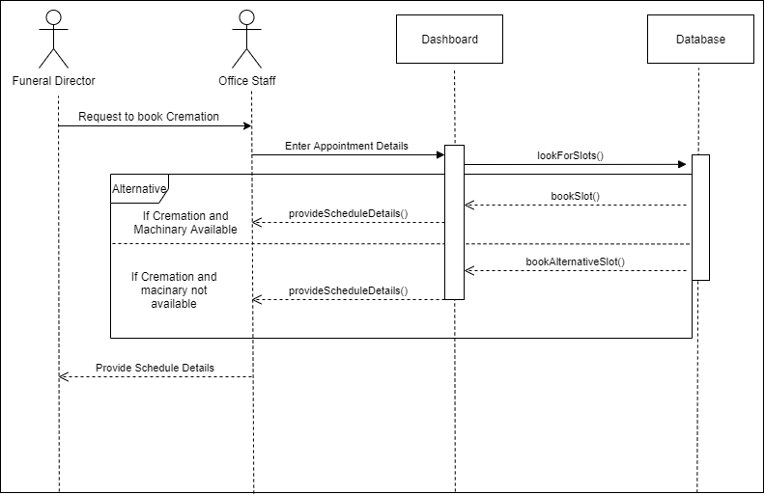
Arrange Flowers Intermediate Description
Flow of Events

1. Order for flowers has been placed
2. Ground Staff opens work order database
3. System displays job order
4. Job order displays how flowers are to be arranged
5. Job order displays where flowers are to be delivered
6. Ground Staff arranges flowers
7. Ground Staff delivers flowers
8. Ground Staff finalises work order
9. Job order requests Client and Ground Staff’s signature

Exception Condition

1.1 If flowers unavailable, Ground Staff checks option to pause order until flowers available, system messages client

Check Machinery Available Intermediate Description
Flow of Events

1. Office Staff requires a list of the available machinery
2. Office Staff selects Equipment Maintenance DB in Dashboard
3. System locates machinery database
4. System displays database showing which machinery is available

Exception Condition

Arrange Flowers:

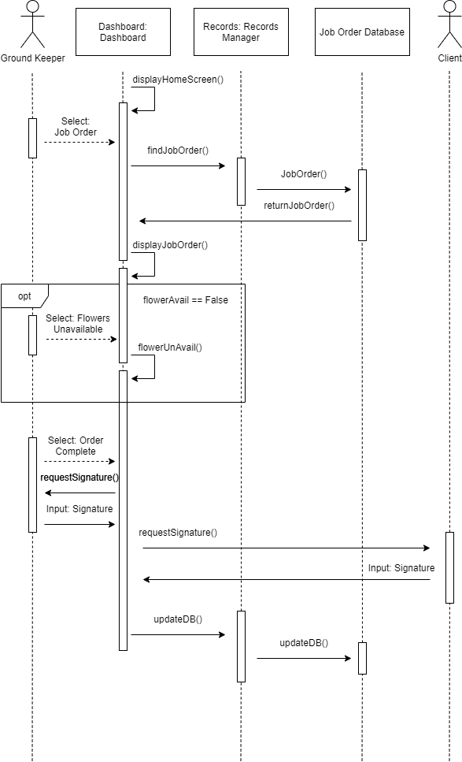
Check Machinery Available:

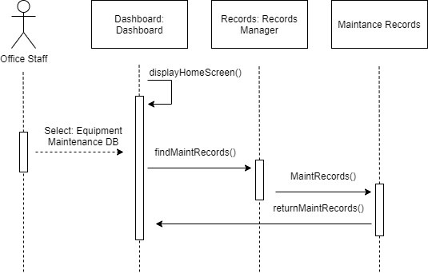
Prepare Cremation Furnace Intermediate Description
Flow of Events

1. A cremation has been scheduled
2. Ground Staff checks work order on system
3. Job order shows time, date of cremation
4. Ground Staff makes sure furnace is clean
5. Ground Staff starts furnace
6. Furnace ignites burners at full heat
7. When furnace reaches optimum heat, furnace turns down heat

Exception Condition

3.1 If gas line is blocked, sensors send warning and furnace shuts down
3.2 If furnace gets too hot, sensors send warning and furnace shuts down

Log into System Intermediate Description
Flow of Events

1. Computer displays login screen
2. User inputs login credentials
3. Computer checks login credentials
4. Computer directs user to desktop of operating system

Exception Condition

1.1 If username or password incorrect, system denies entry
1.2 If username or password incorrect more than 5 times in a row, user locked out of system

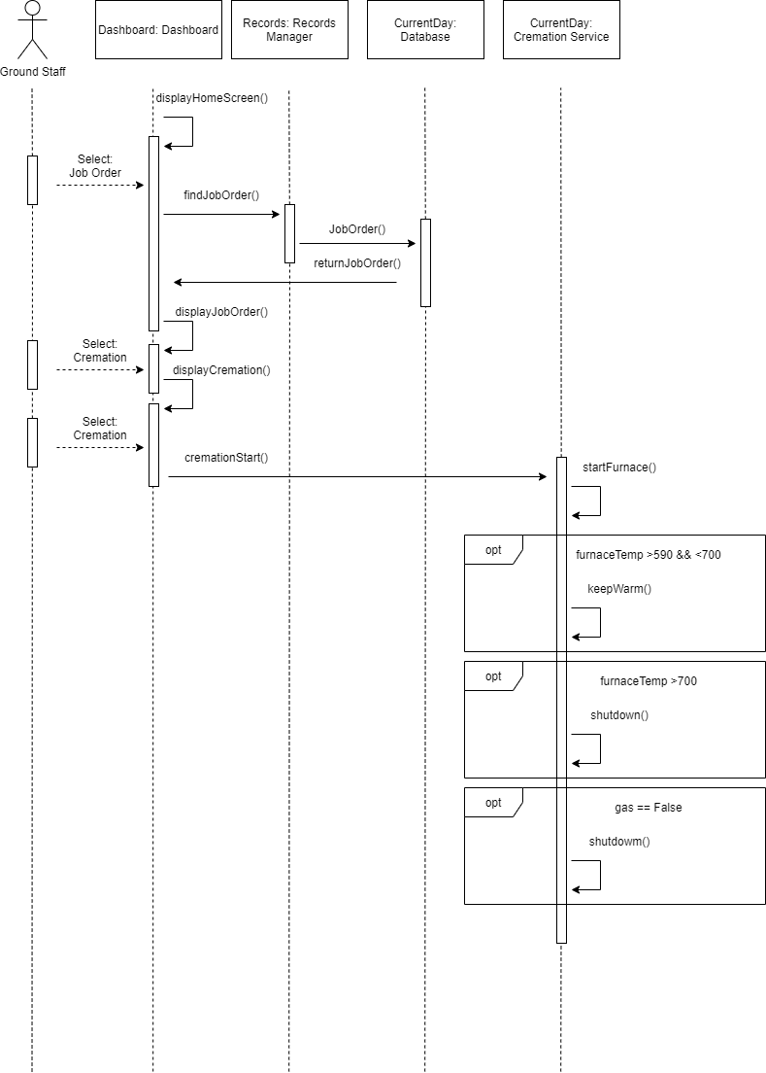
Prepare Cremation Furnace:

Login:
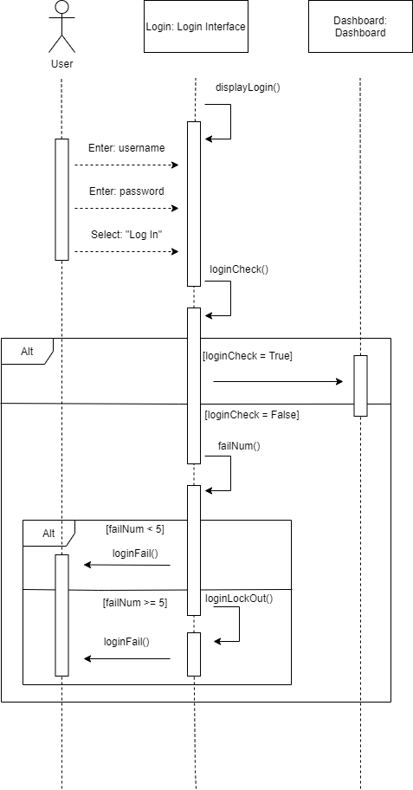

Book Chapel Intermediate Description
Flow of Events

1. Client applies for Chapel session
2. Application is received
3. Application filed
4. Client fills out and submits application
5. System checks orders/reservations
6. System returns the chapel session details and price
7. Client confirms
8. The Clerk enters the total amount required.
9. The UI returns a prompt for payment.
10. The customer selects and enters card details.
11. The UI prints a receipt.
12. The System adds chapel session to reservations list.
13. The Clerk gives the Receipt.

Exception Condition

5.1. If Chapel Session unavailable: System finds and displays next available session

Purchase Commodities Intermediate Description
Flow of Events

1. Client selects the Commodities
2. System checks orders
3. System requests confirmation
4. System requests payment
5. Client confirms
6. The Clerk enters the total amount required.
7. The UI returns a prompt for payment.
8. The customer selects and enters card details.
9. The UI prints a receipt.
10. The System adds to orders list.
11. The Clerk gives the Receipt.

Exception Condition

2.1 if Item/s unavailable system removes item and return error message
3.1 if user selects cancel. End sequence

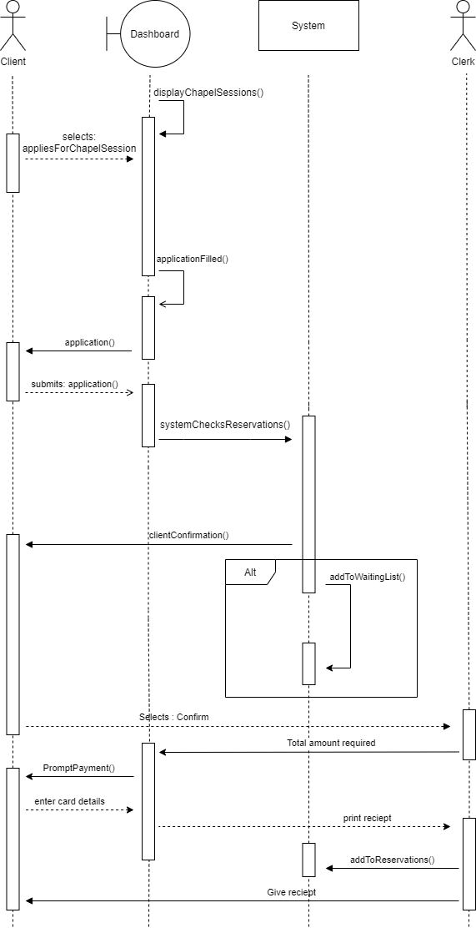
Book Chapel:

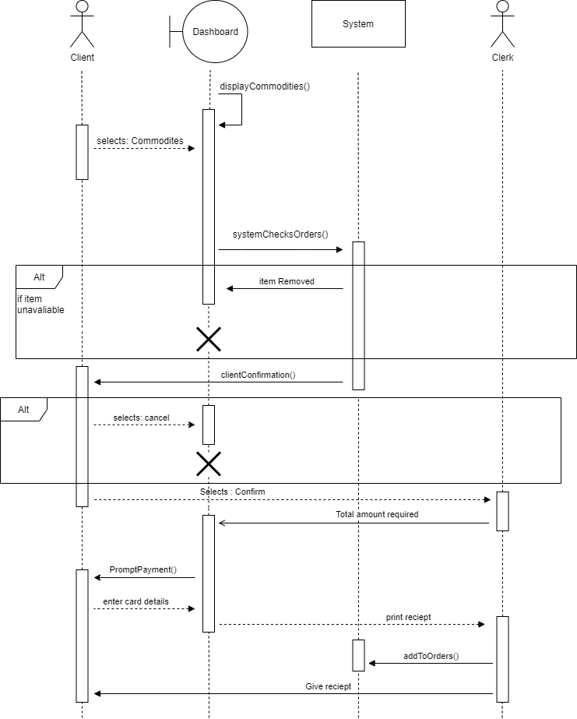
Purchase Commodities:

Rent Wall Space Intermediate Description
Flow of Events

1. Client applies for wall space
2. Application is received
3. Application filled
4. Client fills out and submits application
5. System checks orders/reservations
6. System returns the wall space details and price
7. Client confirms
8. The Clerk enters the total amount required.
9. The UI returns a prompt for payment.
10. The customer selects and enters card details.
11. The UI prints a receipt.
12. The System adds to reservations list.
13. The Clerk gives the Receipt.

Exception Condition

5.1. If no available spaces: system places on waiting list

Maintain Grounds Intermediate Description
Flow of Events

1. Ground staff reach grounds maintenance part of maintain grounds routine.

2. Ground staff walk through car park and gardens picking up rubbish and start cleaning and sanitising the chapel and crematorium rooms.

3. Ground staff go back to view work orders to check for more work

Exception Condition

1.1. Cleaning equipment breaks: Order new equipment and complete other maintenance tasks while waiting.

Rent Wall Space:

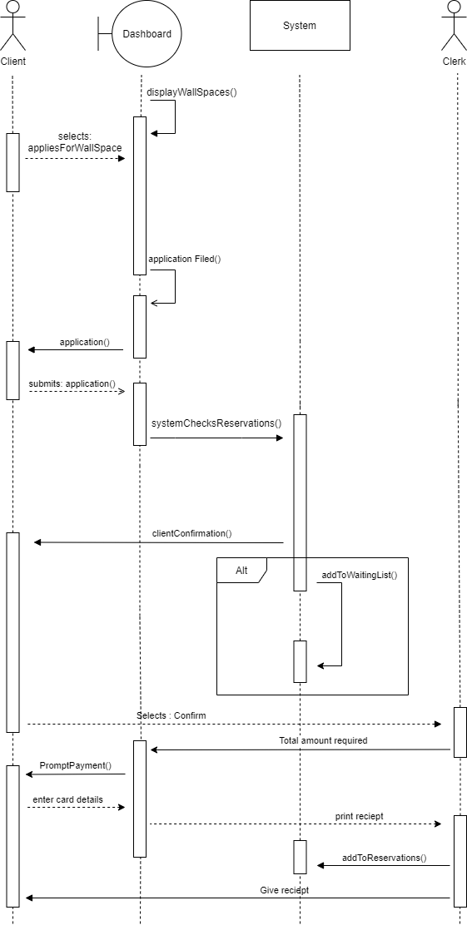
Maintain Grounds:
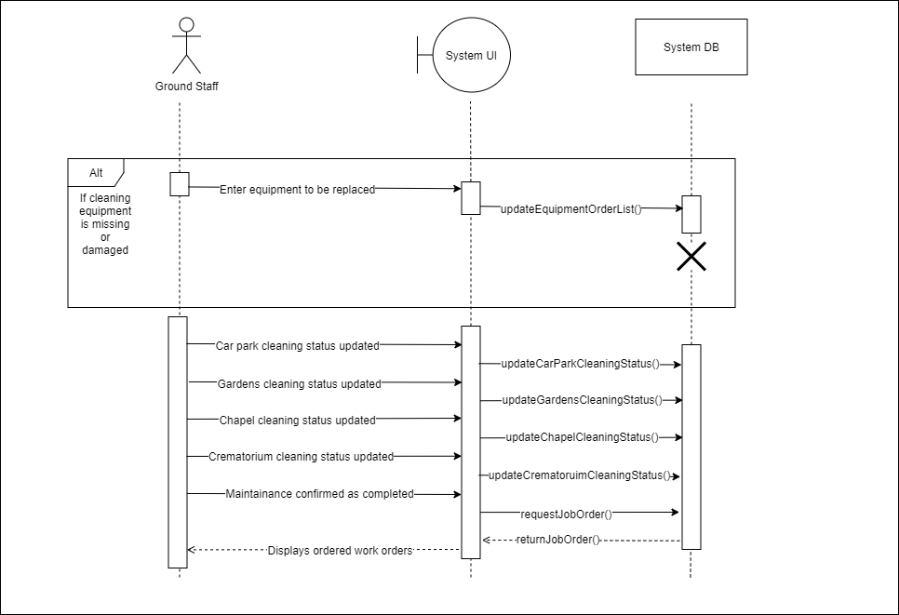
Maintain Machinery Intermediate Description
Flow of Events

1. Ground Staff begin servicing machines used that day
2. Ground staff start cleaning machines used that day
3. Ground staff move to next task on maintenance routine

Exception Condition

2.1. No time left in day for maintaining of machinery: Ground staff are given the option to stay back for overtime or complete the necessary servicing before all other jobs the next working morning.

Prepare Burial Grounds Intermediate Description
Flow of Events

1. Ground staff collect work orders for the day
2. Ground staff move to first grave site and start digging the grave
3. Ground staff set up marquis
4. Ground staff gather lowering slings to leave by the grave
5. Ground staff finish and move to next work order

Exception Condition

2.1. No more grave sites: Order new equipment and complete other maintenance tasks while waiting.

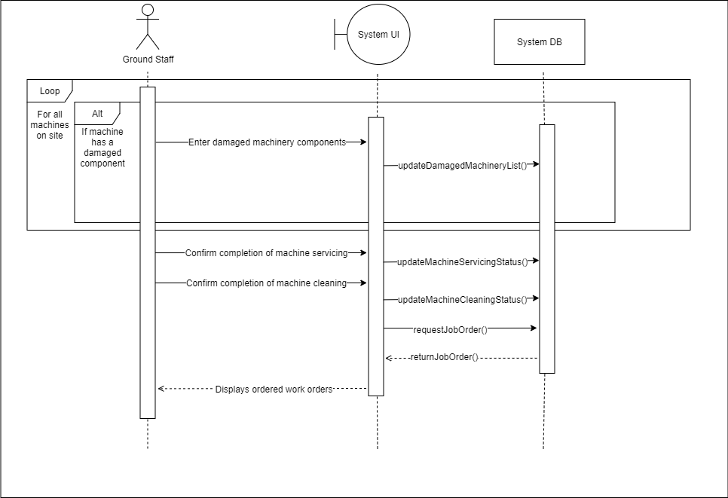
Maintain Machinery:

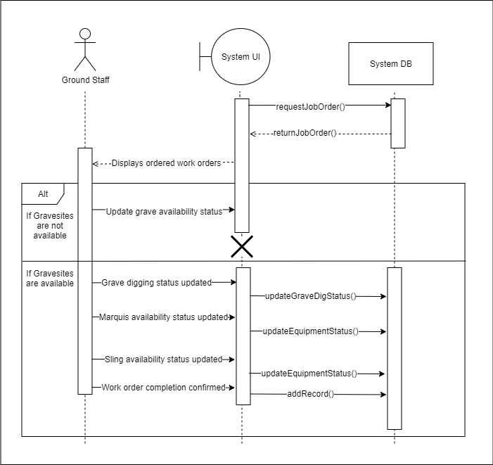
Prepare Burial Grounds:

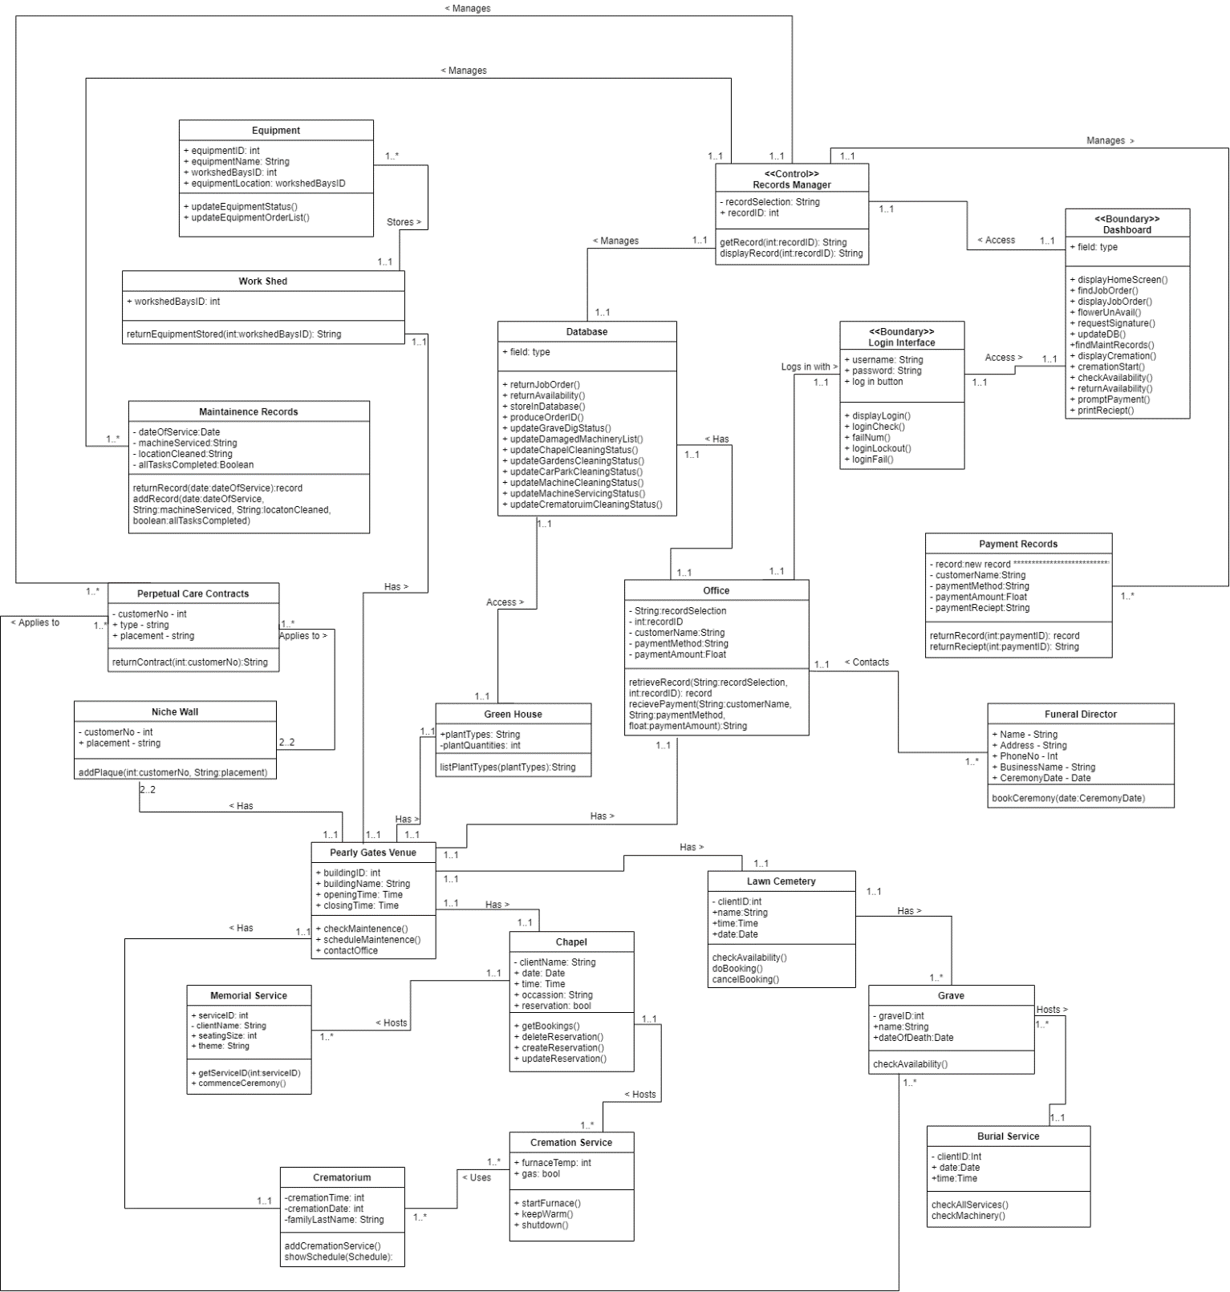
Class Diagram:

Deployment Strategy:

Architecture Style: The architecture style the Development team went with was a layered approach. This best suited our system as we have different levels of the system that rely on other lower levels for the function of the system. Not only does this increase security of User data but also allows us to create subsystems on certain layers in the future for expansion.
Deployment Strategy: The Development team has decided to deploy the new system in parallel with the old system for a variation of reasons. These reasons are that it is a fairly low risk deployment strategy due to the old system being used still we have a stable platform the whole time and it also gives our customers time to adapt to the new software. The Dev team believes using this strategy over a larger period will leave the end result of a much more stable system in the long run.

User Interface:

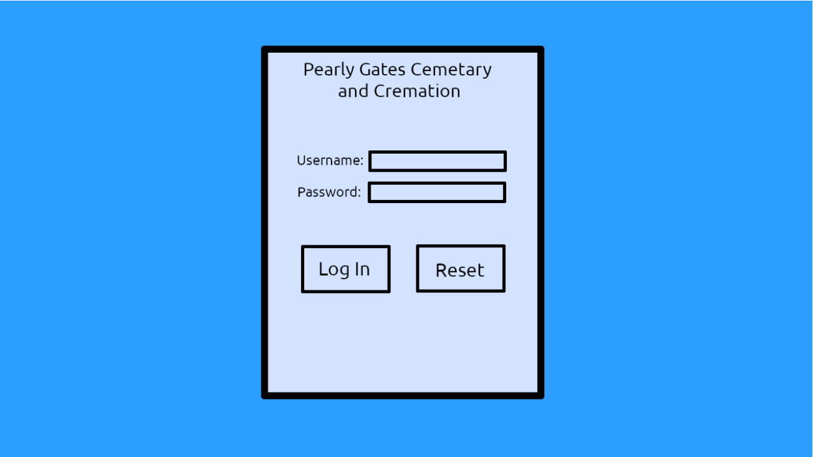
Login:

Minutes of Meeting:

Group: Tue_12-2_G1 Place: Discord Date/Time: 12/05/2020 12pm

In attendance
Joshua Palmer
Ritesh Jogia
Daniel Ward
Isaac Urquhart
Asim Faiaz

Apologies

Agenda
- Begin assignment 2
- Discuss assignment 2
- Complete new Use Case Diagram
- Divide work amongst team

Action sheet

Task | Responsible | Due | Notes
Intermediate Descriptions | Everyone | 19/05/20

Group: Tue_12-2_G1 Place: Discord Date/Time: 19/05/2020 12pm

In attendance
Joshua Palmer
Ritesh Jogia
Daniel Ward
Isaac Urquhart

Apologies
Asim Faiaz

Agenda

- Discuss Feedback
- Fix Use Case Diagram
- Discuss Class Diagram

Action sheet

Task | Responsible | Due | Notes
Redo Use Case Descriptions Based on Feedback | Everyone | 22/05/2020
Attend Next Meeting | Everyone | 22/05/2020 - 3pm

Group: Tue_12-2_G1 Place: Discord Date/Time: 26/05/2020 12pm

In attendance
Joshua Palmer
Ritesh Jogia
Isaac Urquhart
Asim Faiaz

Apologies
Daniel Ward

Agenda

- Complete Class Diagram
- Discuss Sequence Diagram

Action sheet

Task | Responsible | Due | Notes
Work on Class Diagram | Everyone | 29/05/2020
Work on Sequence Diagram | Everyone | 29/05/2020
Attend Next Meeting | Everyone | 29/05/2020 - 3pm

Group: Tue_12-2_G1 Place: Discord Date/Time: 01/06/2020 5:30pm

In attendance
Joshua Palmer
Ritesh Jogia
Isaac Urquhart
Asim Faiaz
Daniel Ward

Apologies

Agenda

- Complete Class Diagram
- Discuss Sequence Diagrams

Action sheet

Task | Responsible | Due | Notes
Work on Sequence Diagram | Everyone | 02/06/2020
Attend Next Meeting | Everyone | 02/06/2020 - 12pm

Group: Tue_12-2_G1 Place: Discord Date/Time: 02/06/2020 5:30pm

In attendance
Joshua Palmer
Ritesh Jogia
Isaac Urquhart
Asim Faiaz
Daniel Ward

Apologies

Agenda

- Complete Class Diagram
- Complete User Interface
- Complete Deployment Strategy
- Complete Report

Action sheet

Task | Responsible | Due | Notes
Finalise Everything | Everyone | 02/06/2020

